<https://www.youtube.com/watch?v=Rtd0gHl4PBo>

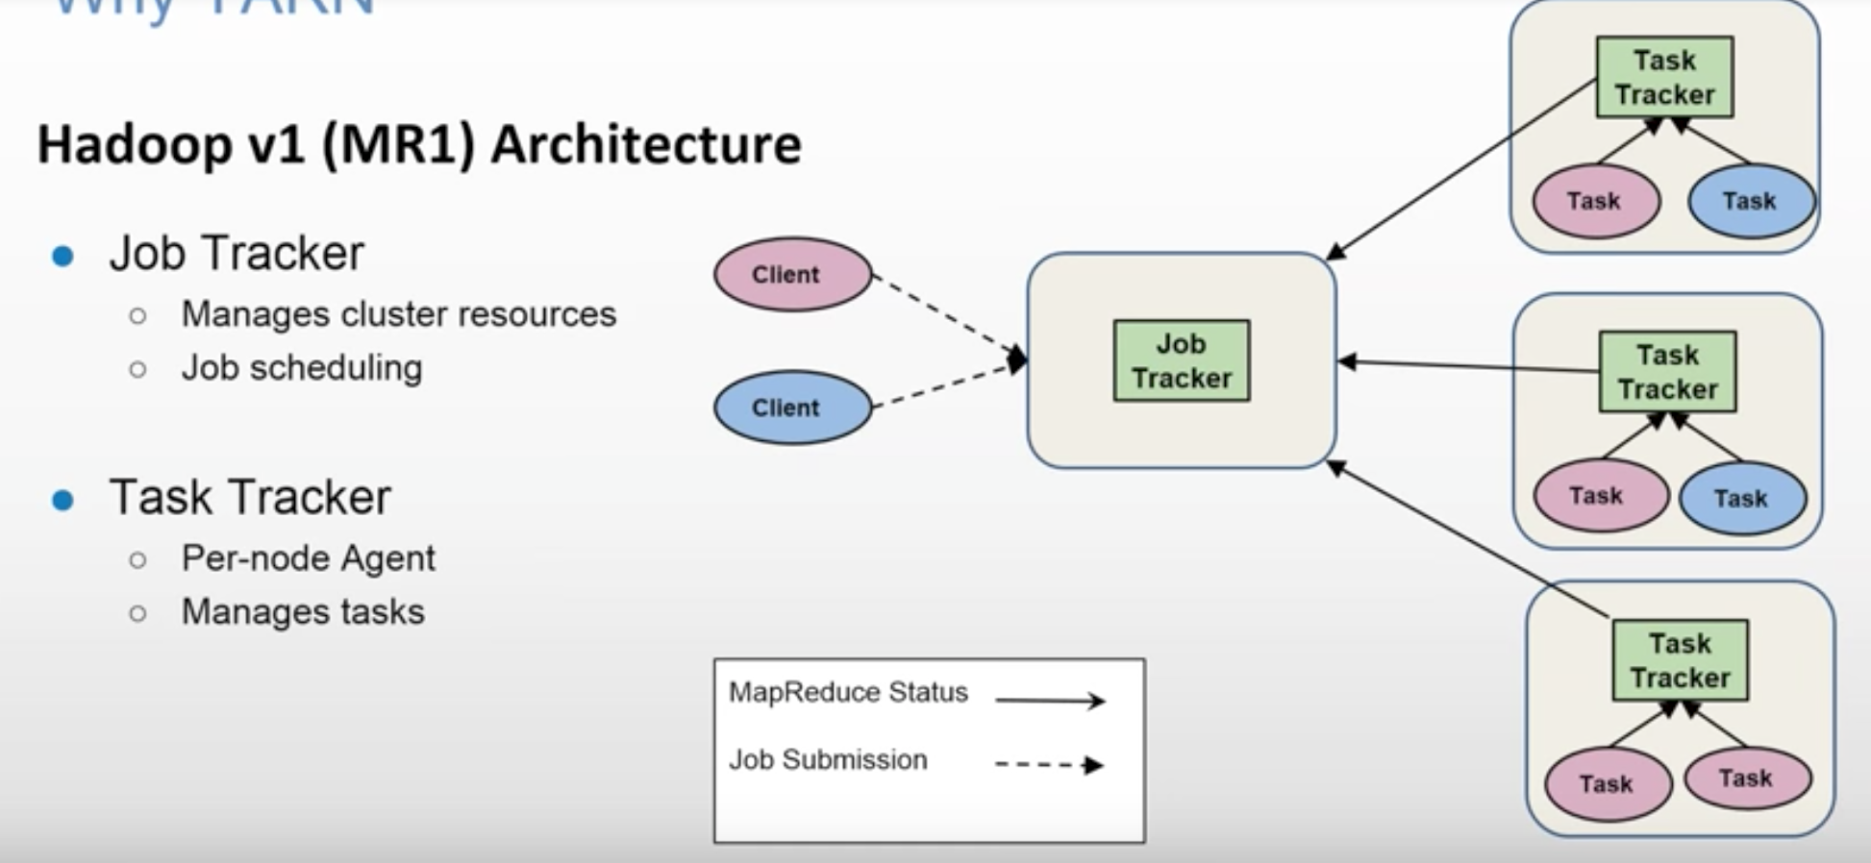

Limitations of Hadoop 1

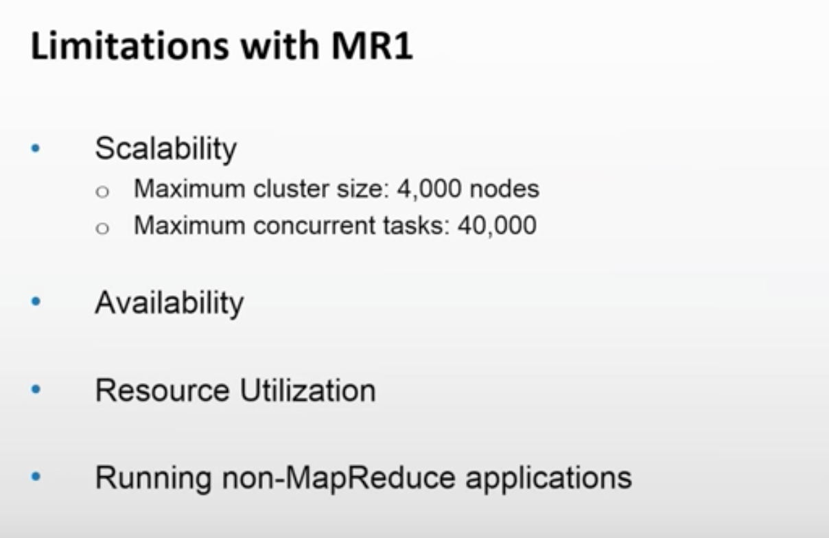

JobTracker is a SPOF. Only traditional MapReduce code can run on Hadoop V1. You cannot run other apps like Storm, Spark, Giraph etc.

*Scalability*

YARN can run on larger clusters than MapReduce 1. MapReduce 1 hits scalability bottlenecks in the region of 4,000 nodes and 40,000 tasks,6 stemming from the fact that the jobtracker has to manage both jobs *and* tasks. YARN overcomes these limitations by virtue of its split resource manager/application master architecture: it is designed to scale up to 10,000 nodes and 100,000 tasks.

In contrast to the jobtracker, each instance of an application—here, a MapReduce job—has a dedicated application master, which runs for the duration of the application.

*Availability*

the large amount of rapidly changing complex state in the jobtracker’s memory (each task status is updated every few seconds, for example) makes it very difficult to retrofit HA into the jobtracker service.

With the jobtracker’s responsibilities split between the resource manager and ap‐ plication master in YARN, making the service highly available became a divide- and-conquer problem: provide HA for the resource manager, then for YARN ap‐ plications (on a per-application basis). And indeed, Hadoop 2 supports HA both for the resource manager and for the application master for MapReduce jobs.

*Utilization*

In MapReduce 1, each tasktracker is configured with a static allocation of fixed-size “slots,” which are divided into map slots and reduce slots at configuration time. A map slot can only be used to run a map task, and a reduce slot can only be used for a reduce task.

In YARN, a node manager manages a pool of resources, rather than a fixed number of designated slots. MapReduce running on YARN will not hit the situation where a reduce task has to wait because only map slots are available on the cluster, which can happen in MapReduce 1. If the resources to run the task are available, then the application will be eligible for them.

Furthermore, resources in YARN are fine grained, so an application can make a request for what it needs, rather than for an indivisible slot, which may be too big (which is wasteful of resources) or too small (which may cause a failure) for the particular task.

*Multitenancy*

In some ways, the biggest benefit of YARN is that it opens up Hadoop to other types of distributed application beyond MapReduce. MapReduce is just one YARN ap‐ plication among many.

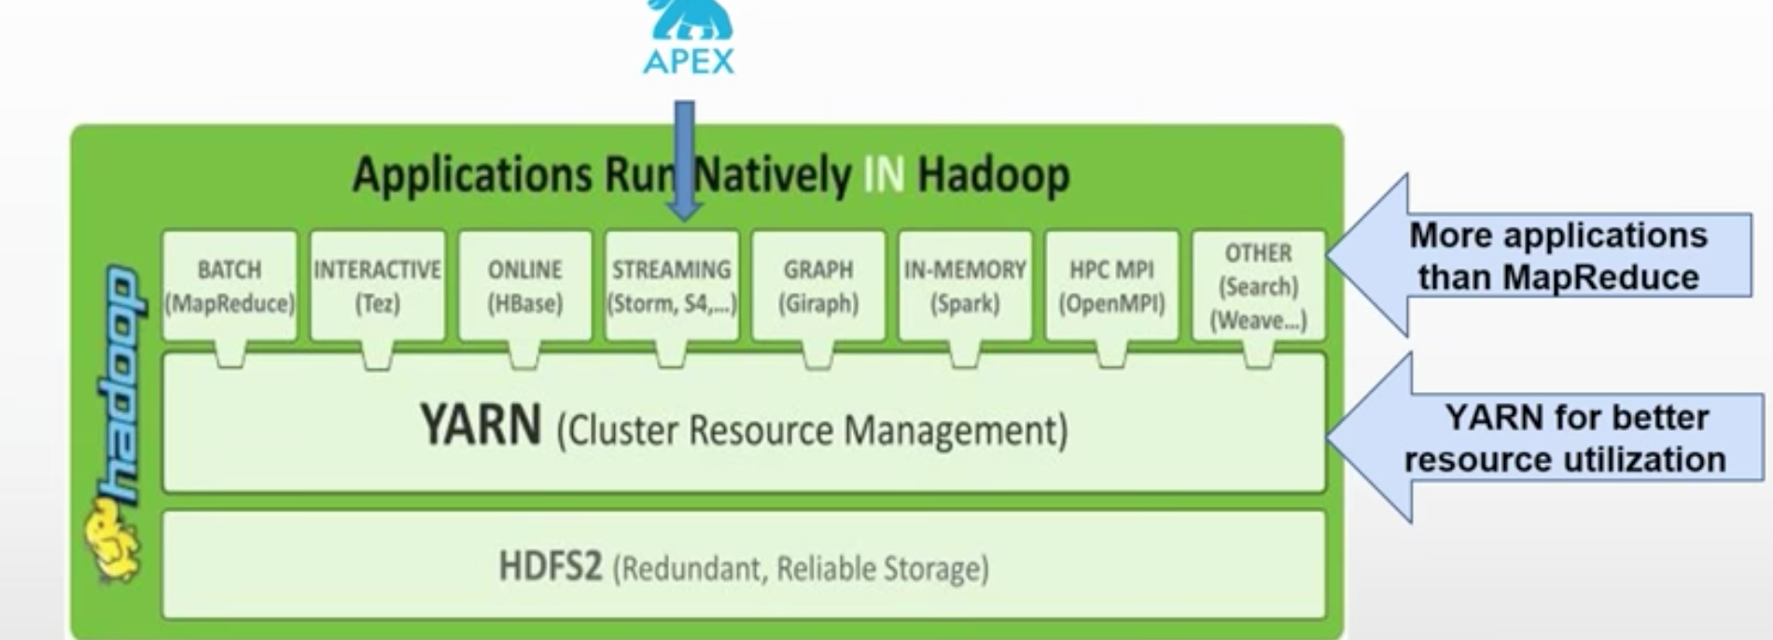

YARN has taken Hadoop beyond Batch Processing.

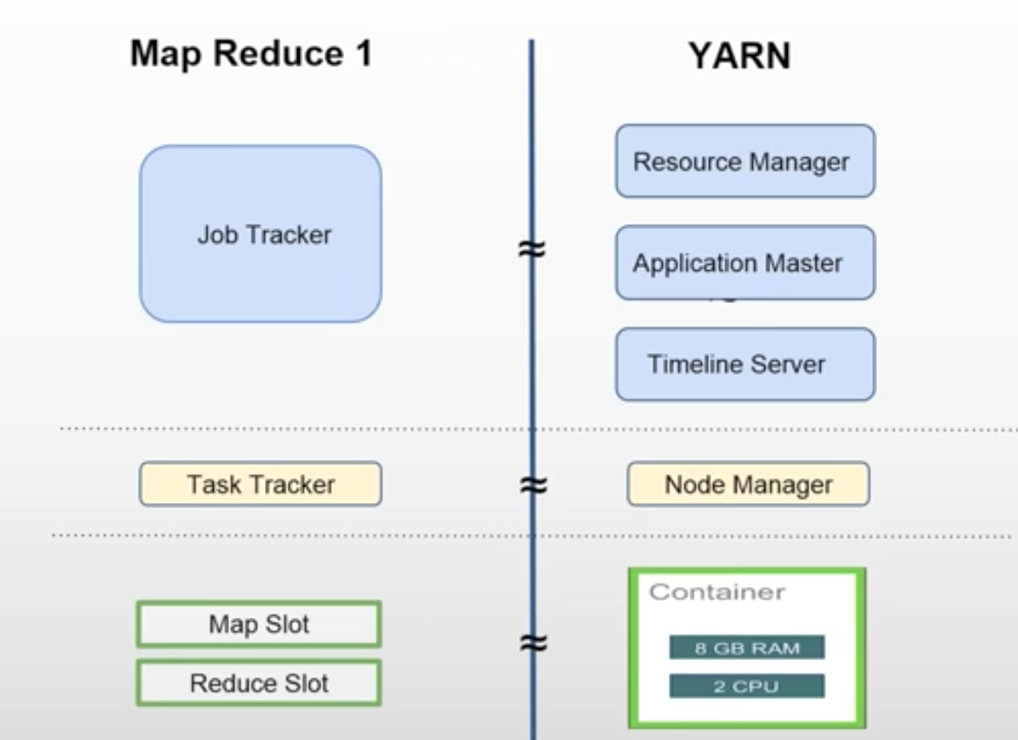

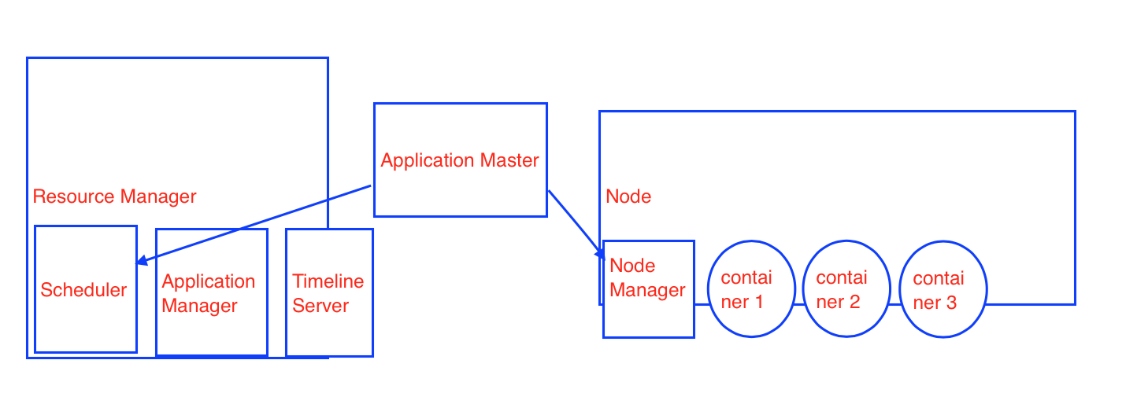

In Hadoop V1, Job Tracker used to many work. In YARN, responsibilities are divided.

Timeline Server keeps the history of all the jobs that were executed.

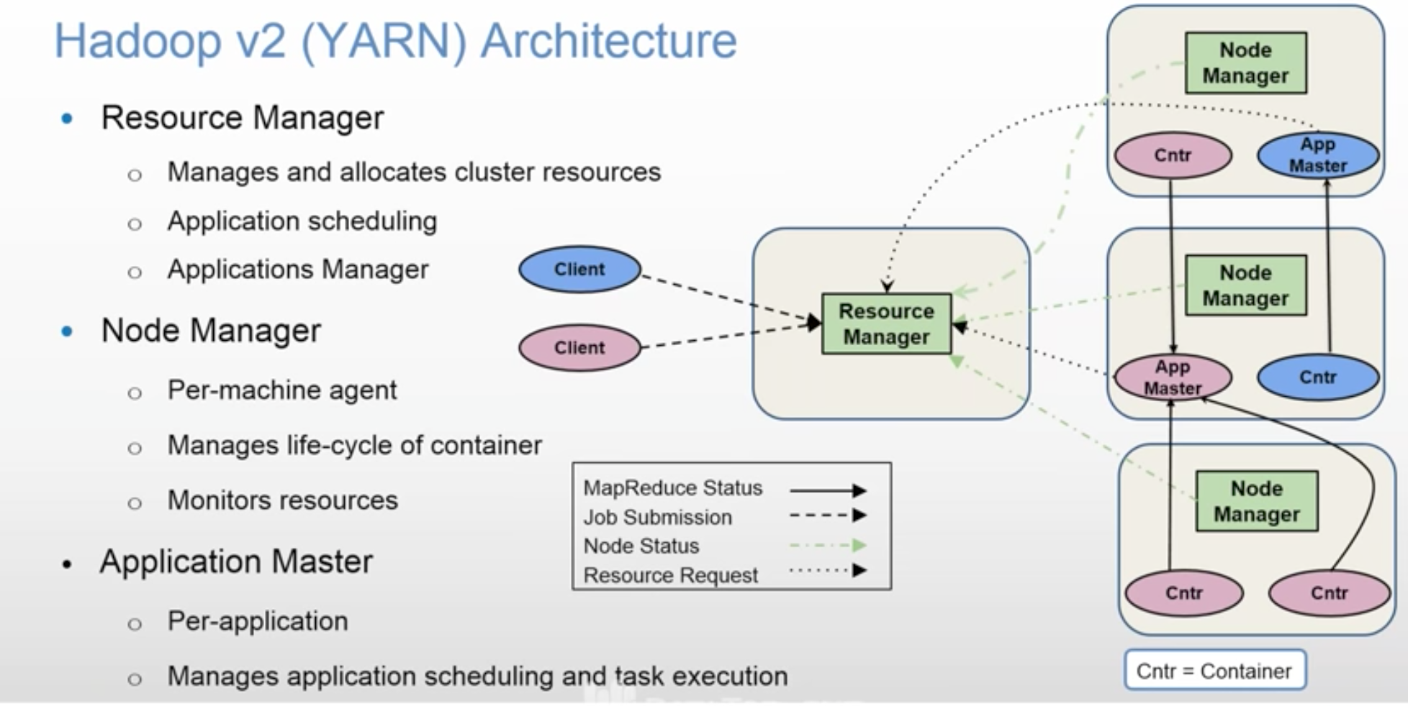

As there are two applications, there are two Application Masters shown in above diagram.

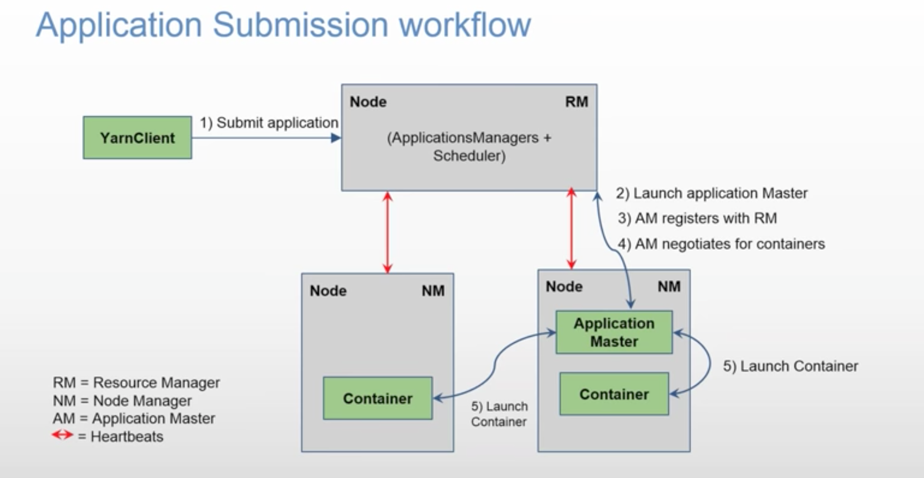

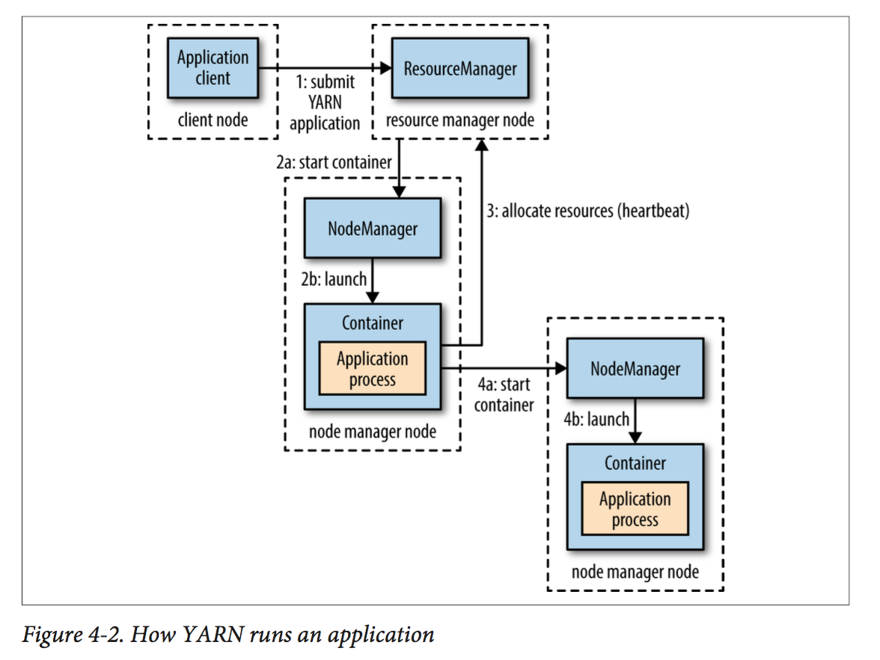

More detailed diagram

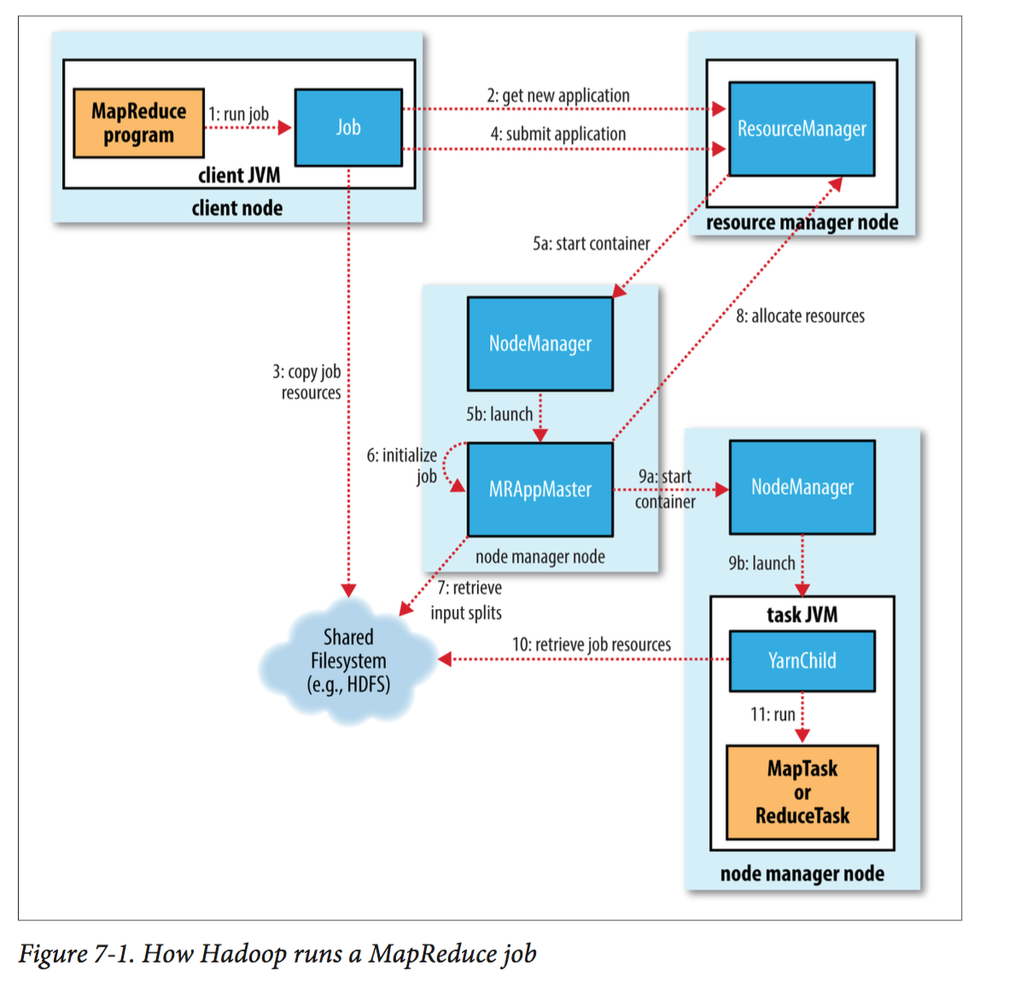

5 main components are involved in running MapReduce job.

* Client
* YARN Resource Manager (has Scheduler and Application Manager)
* YARN Application Master
* YARN Node Manager
* Distributed File System (normally HDFS).

**Client** asks for new Application ID from RM.

RM returns an Application ID to the client.

Client copies required MapReduce jar file to Shared FileSystem.

Then client submits a job to RM using JobSubmitter class.

It computes the number of input splits also. That information is also kept in HDFS.

You can run a MapReduce job with a single method call: **submit**() on a Job object (you can also call **waitForCompletion**(), which submits the job if it hasn’t been submitted already, then waits for it to finish)

The scheduler allocates a container, and the resource manager then launches the application master’s process.

**Application Master** sits in between Resource Manager and Node Manager.

There is one and only one Application Master per Application.

It retrieves number of input splits computed by client and kept in HDFS.

Using the number of input splits, it negotiates number of containers from RM’s Scheduler.

It contacts NMs on nodes and tells them to launch containers.

It tracks the progress of tasks running on nodes under the surveillance of NodeManager. NodeManager’s job is to keep telling Resource Manager about utilized resources and node’s health.

NOTE: Application Master can also be a custom code.

**Uber Task (**Very Important concept)

Based on number of input splits, Application Master decides how many mappers are required and client has told number of reducers using setNumReduceTasks() method.

If job is too small, then Application Master decides to run the MapReduce in its own container sequentially instead of running them in many nodes in parallel. This is called Uber Task.

What qualifies as a small job?

By default, a small job is one that has less than 10 mappers, only one reducer, and an input size that is less than the size of one HDFS block.

(Note that these values may be changed for a job by setting mapreduce.job.ubertask.maxmaps, mapreduce.job.ubertask.maxreduces, and map reduce.job.ubertask.maxbytes.) Uber tasks must be enabled explicitly (for an individual job, or across the cluster) by setting mapreduce.job.ubertask.enable to true.

If the job does not qualify for running as an uber task, then the application master requests containers for all the map and reduce tasks in the job from the resource manager.

Requests for map tasks are made first and with a higher priority than those for reduce tasks, since all the map tasks must complete before the sort phase of the reduce can start. Requests for reduce tasks are not made until 5% of map tasks have completed.

Reduce tasks can run anywhere in the cluster, but requests for map tasks have **data locality** constraints that the scheduler tries to honor.

**By default, each map and reduce task is allocated 1,024 MB of memory and one virtual core.** The values are configurable on a per-job basis via the following properties: mapreduce.map.memory.mb

mapreduce.reduce.memory.mb

mapreduce.map.cpu .vcores

mapreduce.reduce.cpu.vcores.

Once a task has been assigned resources for a container on a particular node by the resource manager’s scheduler, the application master starts the container by contacting the node manager.

The task is executed by a Java application whose main class is **YarnChild**.

The YarnChild runs in a dedicated JVM, so that any bugs in the user-defined map and reduce functions (or even in YarnChild) don’t affect the node manager—by causing it to crash or hang, for example.

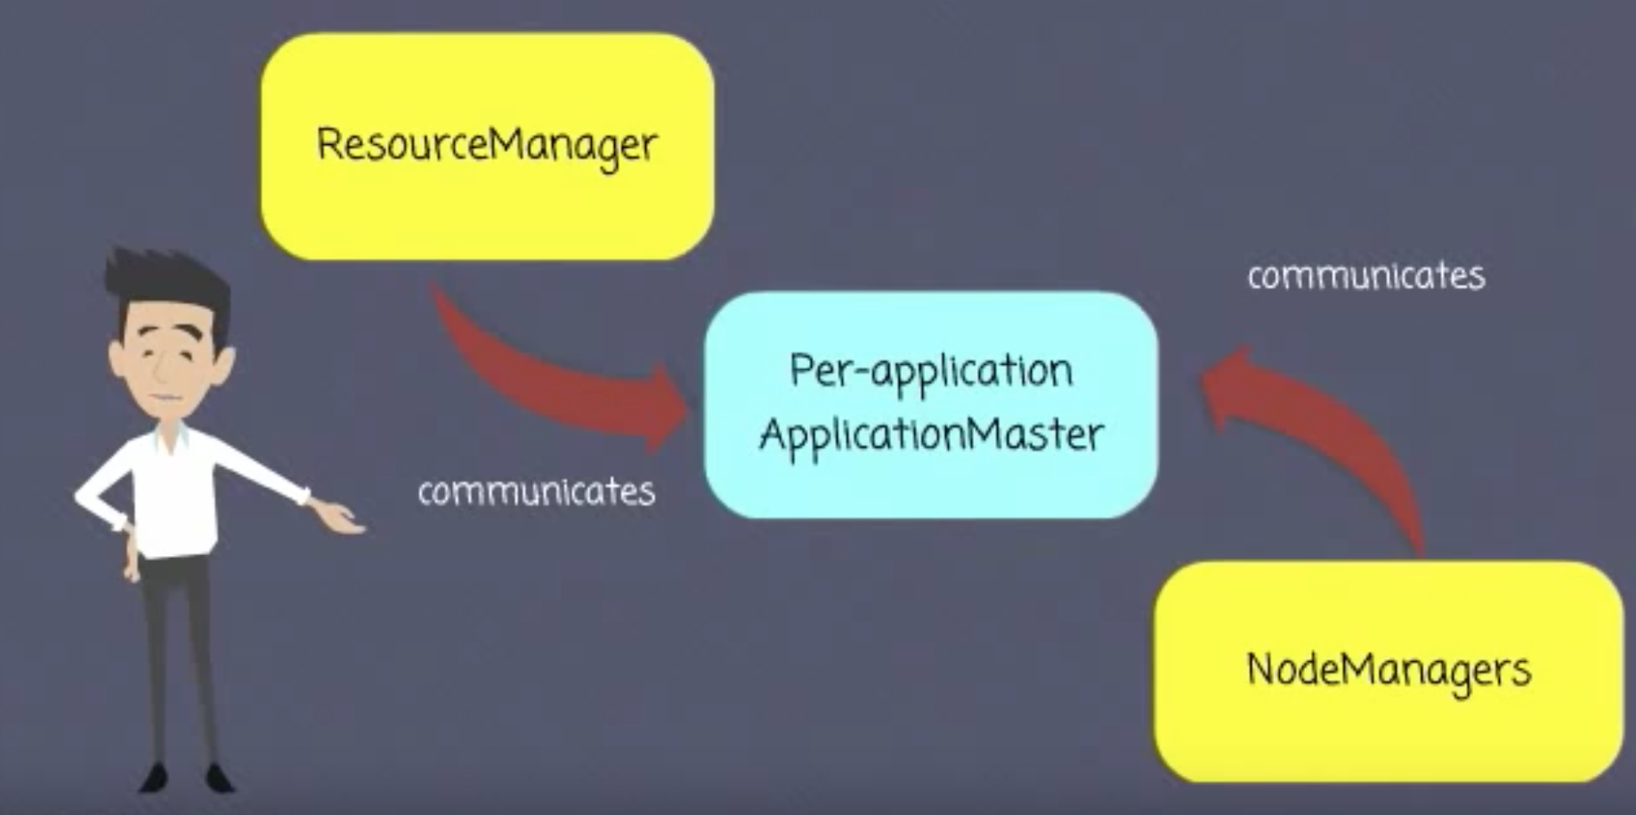

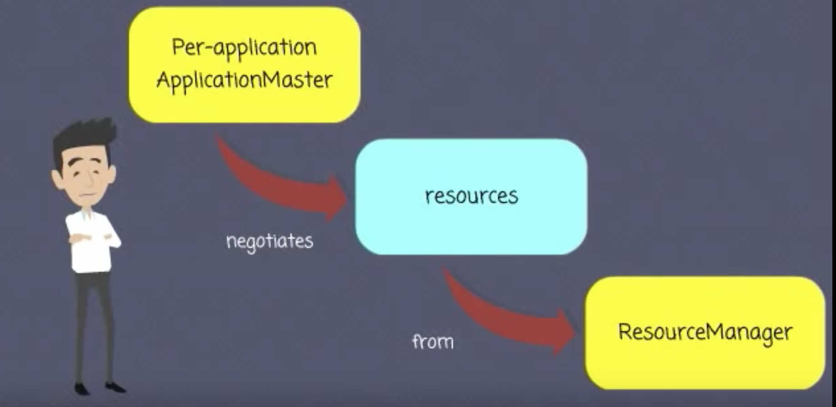

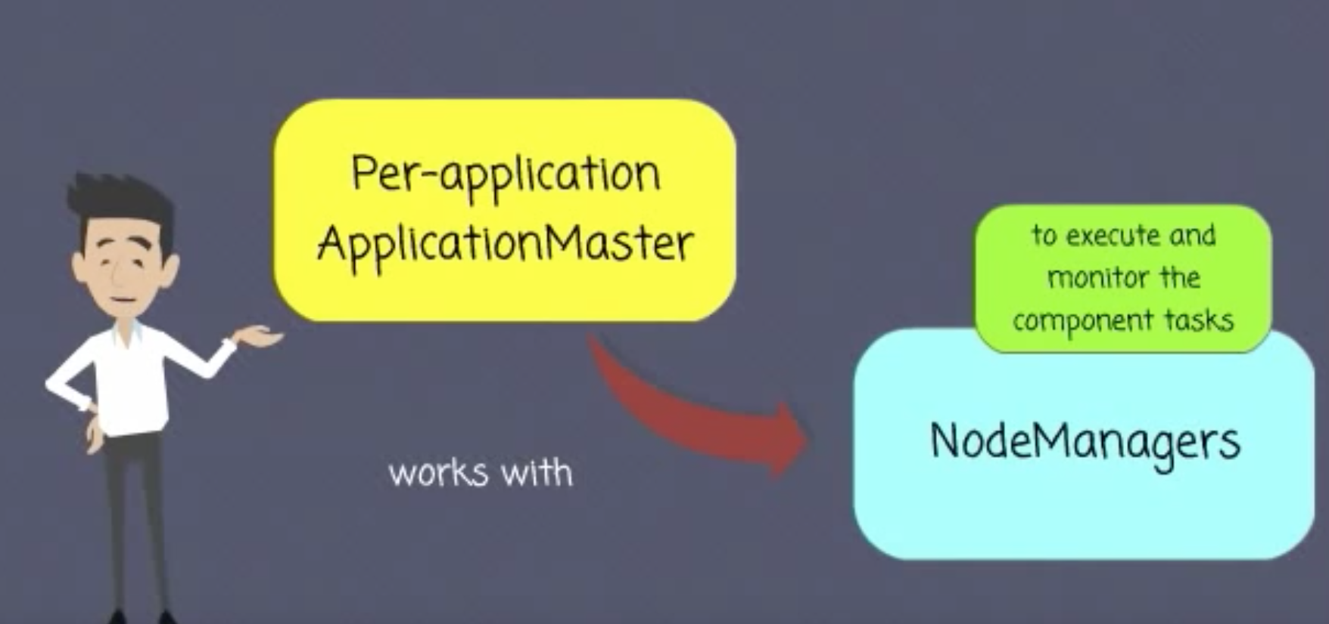

How the communication happens between RM and Application Master?

Application Master is a custom code. If it requires 3 containers, but RM has only 2 available, then RM can go back to Application Master saying come back after some time or you can write Application Master code in such a way that it can accept lower number of containers also.

YARN allows an application to specify locality constraints for the containers it is requesting. Locality constraints can be used to request a container on a specific node or rack, or anywhere on the cluster (off-rack).

Sometimes the locality constraint cannot be met, in which case either no allocation is made or, optionally, the constraint can be loosened.

As per the proximity and availability of the nodes, YARN schedules your job.

It tries to run the job on the closest node where block replica is available. If node is busy because of other containers running in it, then

it finds another node in the same rack. If that is also not available then it goes to a node on another rack.

In the common case of launching a container to process an HDFS block (to run a map task in MapReduce, say), the application will request a container on one of the nodes hosting the block’s three replicas, or on a node in one of the racks hosting the replicas, or, failing that, on any node in the cluster.

You submit a job to RM. RM’s scheduler schedules the job.

**Node Manager** keeps sending heart beats to RM, so that RM know what NMs are up. It also sends utilization of resources information to RM.

Node Manager is responsible to launch a container and killing it when job is over.

**Scheduler** will schedule the job in the cluster. So, your job’s state changes from

accepted to running.

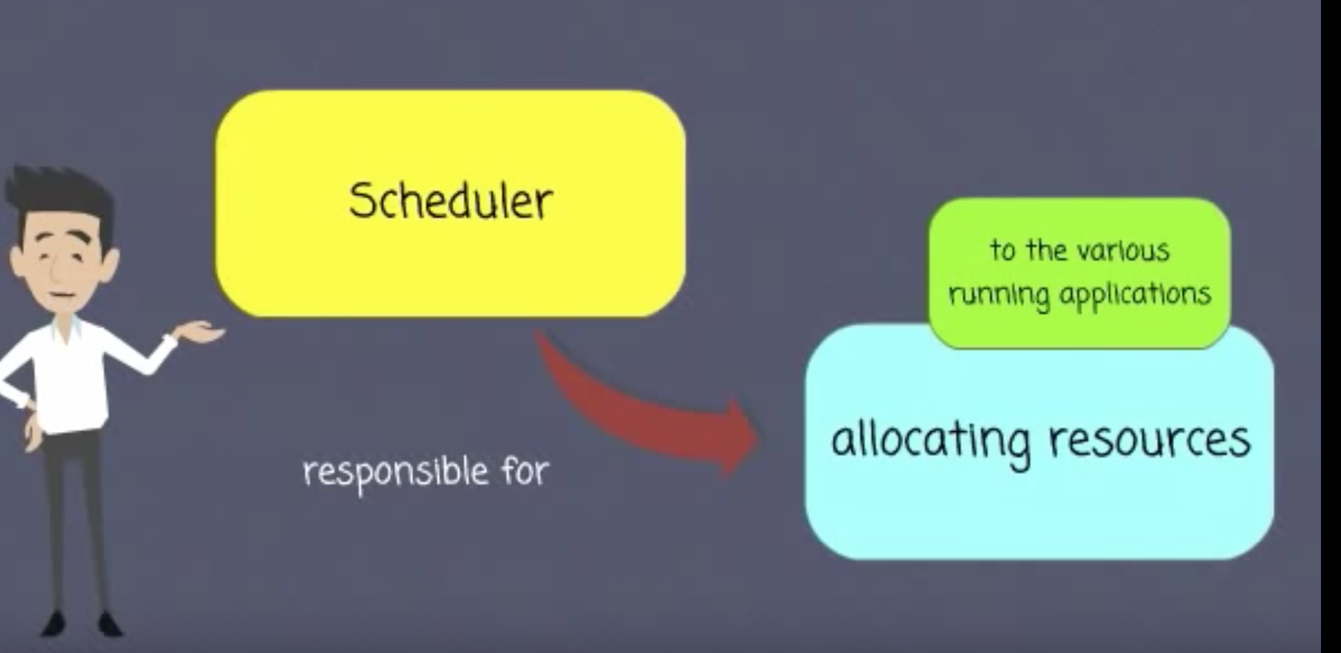

The Scheduler allocates a container, and the Application Manager then launches the Application Master’s process there.

3 different types of schedulers available: (pg. 85 of book)

- FIFO **- default**

- Capacity

- Fair Share

FIFO scheduler queues up the job as it comes and submits them on FIFO basis. If long running job comes first and then short running job, later one has to wait till first one finishes.

This may not be the right scheduling when you want to share the same cluster for multiple jobs.

Capacity scheduler lets you configure multiple queues and set capacity to them. E.g. prod and dev queues with 40% and 60% capacity respectively. When prod job is submitted and if dev job arrives, dev job will start running immediately. Prod job will use 40% capacity (cpu, memory etc) and dev job will use 60%. If another dev job arrives, two dev jobs will share 30%-30% resources.

Fair Share scheduler uses only one queue. It fairly shares the resources (capacity) as and when new job arrives.

You can configure multiple queues in such a way that default is ‘Fair Share’ , but prod queue is overridden with ‘FIFO’ and dev uses the default ‘Faire Share’ (see pg 91 in the book)

For Capacity and Fair Share or mixed types, you need provide queue configuration as shown in the book.

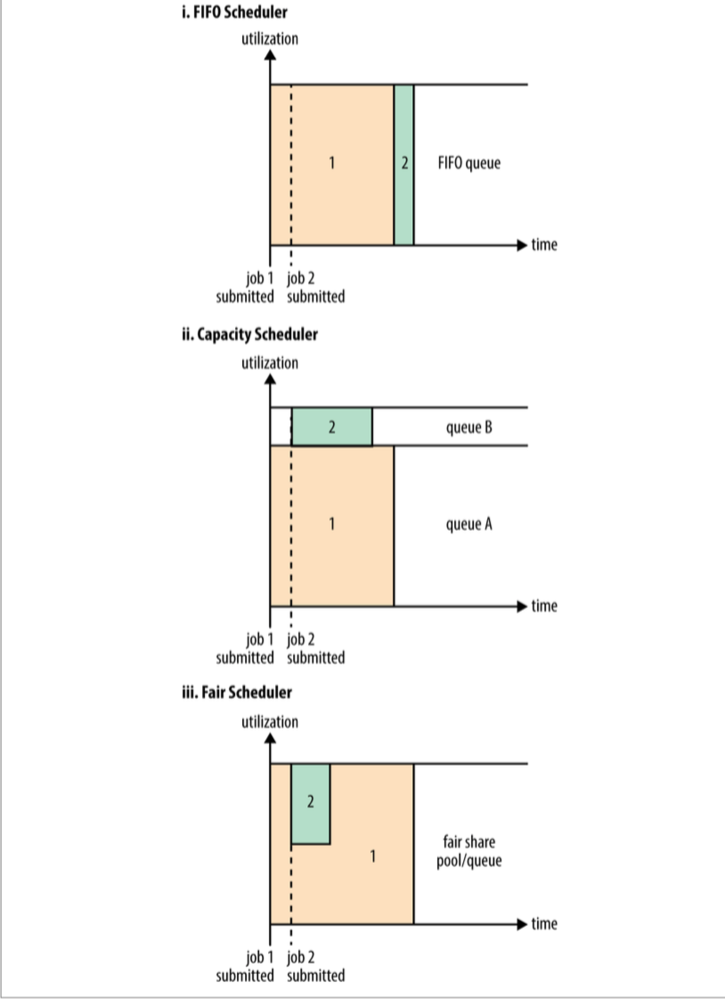

You can submit a job with following parameter specifying a job queue name

-D mapreduce.job.queuename=dev

**What is Delay Scheduling?**

Read about data locality first in SampleHadoopProject. It is the most important concept in Hadoop after parallel processing of data.

All the YARN schedulers try to honor **locality** requests. On a busy cluster, if an application requests a particular node, there is a good chance that other containers are running on it at the time of the request. The obvious course of action is to immediately loosen the locality requirement and allocate a container on the same rack. However, it has been observed in practice that waiting a short time (no more than a few seconds) can dramatically increase the chances of being allocated a container on the requested node, and therefore increase the efficiency of the cluster. This feature is called *delay scheduling*, and it is supported by both the Capacity Scheduler and the Fair Scheduler**.**

**Timeline server** keeps history of jobs that were executed.

**Job/Tasks Progress and Updates**

A job and each of its tasks have a *status*, which includes such things as the state of the job or task (e.g., running, successfully completed, failed), the progress of maps and reduces, the values of the job’s counters, and a status message or description (which may be set by user code).

When a task is running, it keeps track of its *progress* (i.e., the proportion of the task completed). For map tasks, this is the proportion of the input that has been processed. For reduce tasks, it’s a little more complex, but the system can still estimate the pro‐ portion of the reduce input processed. It does this by dividing the total progress into three parts, corresponding to the three phases of the shuffle.

For example, if the task has run the reducer on half its input, the task’s progress is 5/6, since it has completed the copy and sort phases (1/3 each) and is halfway through the reduce phase (1/6).

What is counter?

Tasks (Mapper/Reducer) keeps track of many numbers like number of output record from a mapper. Number of input records to reducer etc.

Along with this, your mapper/reducer code can have its custom counters. E.g. if the input is malformed and cannot be processed, mapper wants to keep the count of those records.

All these counters will be displayed in console as job progresses.

See the example on pg 169 of the book.

The resource manager web UI displays all the running applications with links to the web UIs of their respective application masters, each of which displays further details on the MapReduce job, including its progress.

14/09/12 06:38:11 INFO input.FileInputFormat: **Total input paths to process : 101**

14/09/12 06:38:11 INFO impl.YarnClientImpl: Submitted application

application_1410450250506_0003

14/09/12 06:38:12 INFO mapreduce.Job: **Running job: job_1410450250506_0003**

14/09/12 06:38:26 INFO mapreduce.Job: map 0% reduce 0%

...

14/09/12 06:45:24 INFO mapreduce.Job: **map 100% reduce 100%**

14/09/12 06:45:24 INFO mapreduce.Job: **Job job_1410450250506_0003 completed**

**successfully**

14/09/12 06:45:24 INFO mapreduce.Job: **Counters: 49**

File System Counters

FILE: Number of bytes read=93995

FILE: Number of bytes written=10273563

FILE: Number of read operations=0

FILE: Number of large read operations=0

FILE: Number of write operations=0

HDFS: Number of bytes read=33485855415

HDFS: Number of bytes written=904

HDFS: Number of read operations=327

HDFS: Number of large read operations=0

HDFS: Number of write operations=16

Job Counters

**Launched map tasks=101**

**Launched reduce tasks=8**

Data-local map tasks=101

Total time spent by all maps in occupied slots (ms)=5954495

Total time spent by all reduces in occupied slots (ms)=74934

Total time spent by all map tasks (ms)=5954495

Total time spent by all reduce tasks (ms)=74934

Total vcore-seconds taken by all map tasks=5954495

Total vcore-seconds taken by all reduce tasks=74934

Total megabyte-seconds taken by all map tasks=6097402880

Total megabyte-seconds taken by all reduce tasks=76732416

Map-Reduce Framework

**Map input records=1209901509**

**Map output records=1143764653**

Map output bytes=10293881877

Map output materialized bytes=14193

**Input split bytes=14140**

Combine input records=1143764772

Combine output records=234

Reduce input groups=100

Reduce shuffle bytes=14193

Reduce input records=115

Reduce output records=100

Spilled Records=379

**Shuffled Maps =808**

Failed Shuffles=0

Merged Map outputs=808

GC time elapsed (ms)=101080

CPU time spent (ms)=5113180

Physical memory (bytes) snapshot=60509106176

Virtual memory (bytes) snapshot=167657209856

Total committed heap usage (bytes)=68220878848

Shuffle Errors

BAD_ID=0

CONNECTION=0

IO_ERROR=0

WRONG_LENGTH=0

WRONG_MAP=0

WRONG_REDUCE=0

File Input Format Counters

Bytes Read=33485841275

File Output Format Counters

Bytes Written=90

During the course of the job, the client receives the latest status by polling the application master every second

When the application master receives a notification that the last task for a job is com‐ plete, it changes the status for the job to “successful.” Then, when the Job polls for status, it learns that the job has completed successfully, so it prints a message to tell the user and then returns from the waitForCompletion() method. Job statistics and counters are printed to the console at this point.

“Orelly.Hadoop.The.Definitive.Guide.4th.Edition2015.3.pdf” book doesn’t show an example using YarnClient. See Chapter 6 (Developing a MapReduce Application)

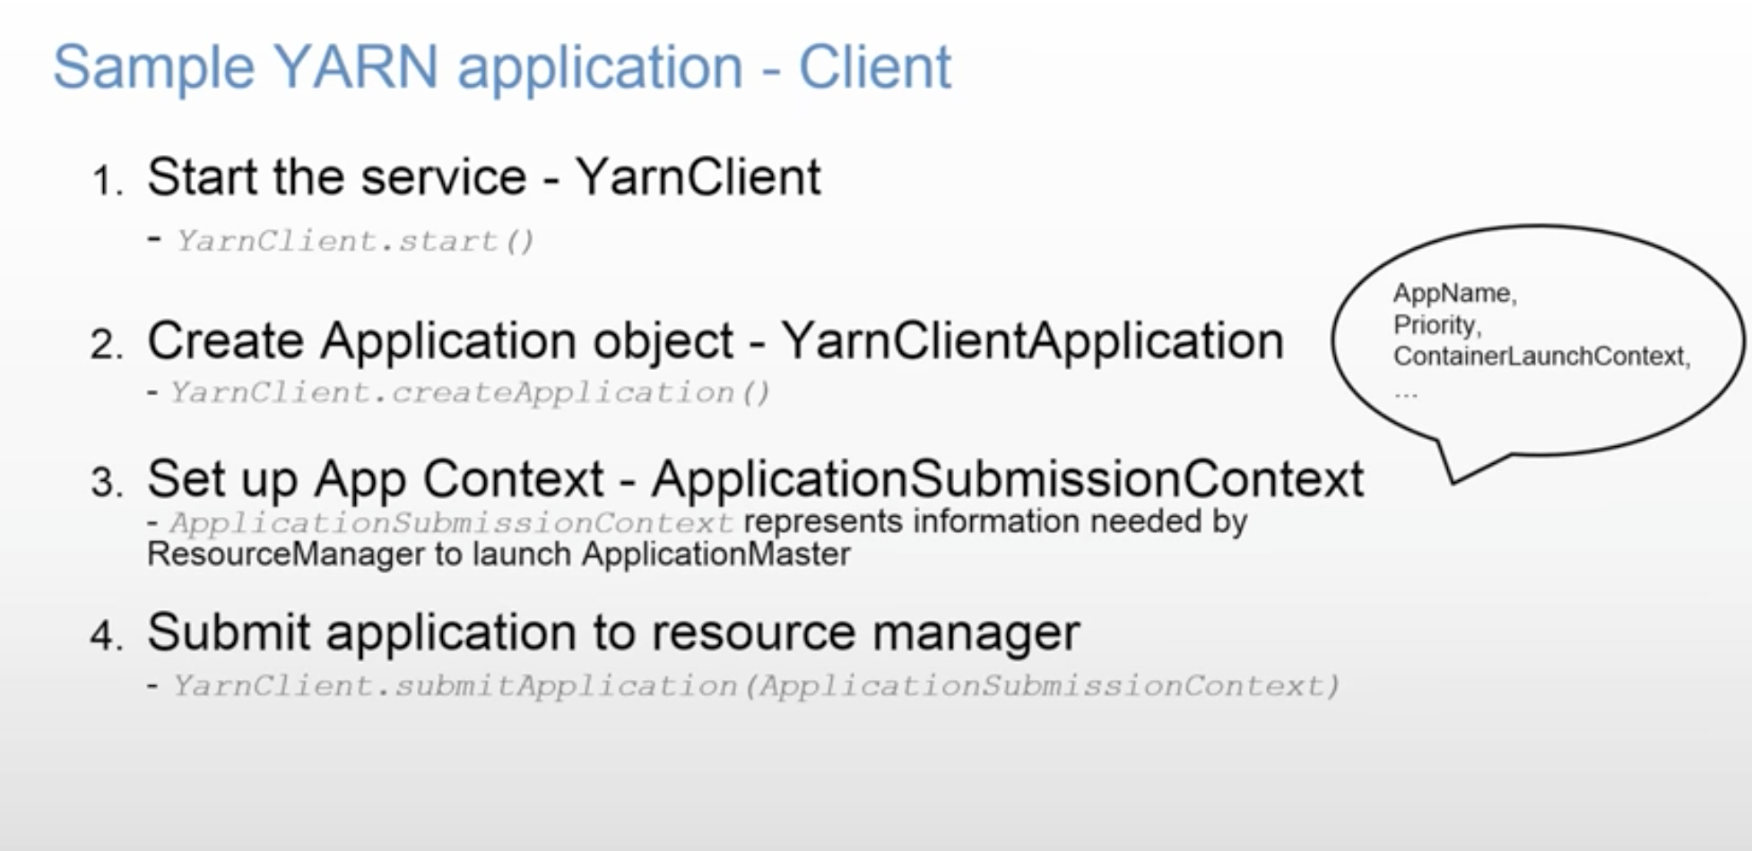

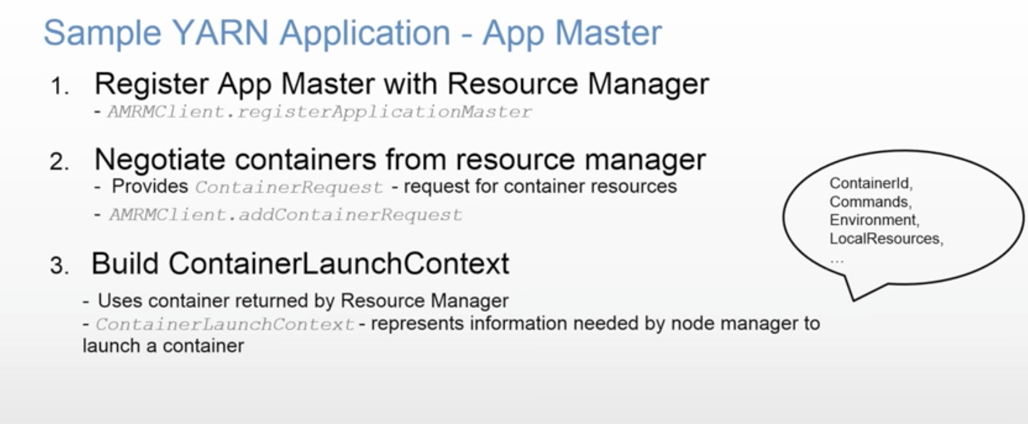

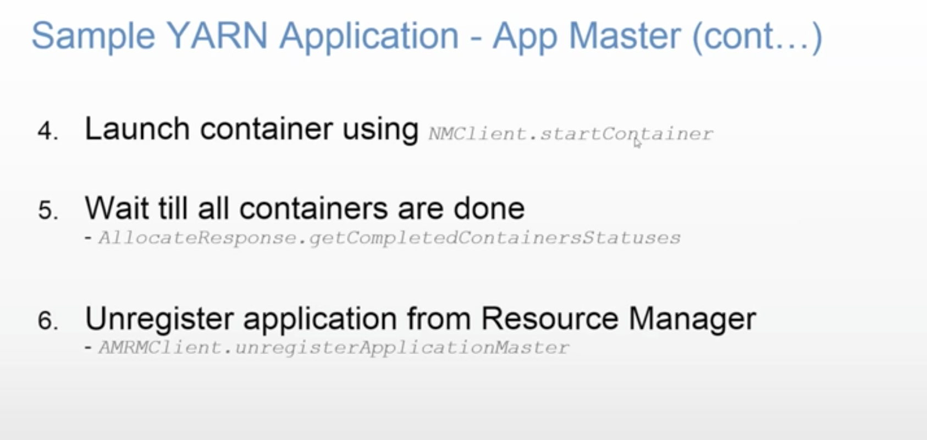

You might have a need where two containers needs to share data. You can configure locality of the containers to be on the same node, so that they don’t use much network. Ideally, you should write independent applications.

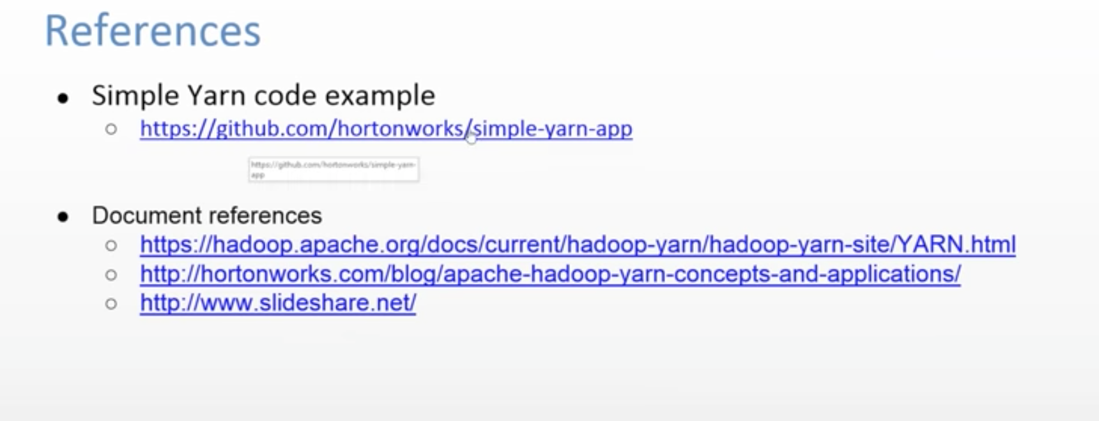



**Failures (pg 193 of book)**

**RM Failure**

You can have **Stand By RM**. So, if primary RM fails, then Stand By RM is promoted as primary RM.

Information about all the running applications is stored in a highly available state store **(backed by ZooKeeper or HDFS)**, so that the standby can recover the core state of the failed active resource manager. Node manager information is not stored in the state store since it can be reconstructed relatively quickly by the new resource manager as the node managers send their first heartbeats.

How does it handle long running jobs?

Jobs can be run for months long. Hadoop takes care of failure of nodes.

How Application Master is started?

RM can launch it on any available Node based on its availability.

**Task Failure**

Consider first the case of the task failing. The most common occurrence of this failure is when user code in the **map or reduce task throws a runtime exception**. If this happens, the task JVM reports the error back to its parent application master before it exits. The error ultimately makes it into the user logs. The application master marks the task **attempt as *failed***, and frees up the container so its resources are available for another task.

For Streaming tasks, if the Streaming process exits with a nonzero exit code, it is marked as failed. This behavior is governed by the stream.non.zero.exit.is.failure property (the default is true).

Another failure mode is the **sudden exit of the task JVM**—perhaps there is a JVM bug that causes the JVM to exit for a particular set of circumstances exposed by the MapReduce user code. In this case, the node manager notices that the process has exited and informs the application master so it can mark the attempt as failed.

**Hanging tasks** are dealt with differently. The application master notices that it hasn’t received a progress update for a while and proceeds to mark the task as failed. The task JVM process will be killed automatically after this period.3 The **timeout period** after which tasks are considered failed is **normally 10 minutes and can be configured on a per-job basis (or a cluster basis)** by setting the **mapreduce.task.timeout** property to a value in milliseconds.

Setting the timeout to a value of zero disables the timeout, so long-running tasks are never marked as failed. In this case, a hanging task will never free up its container, and over time there may be cluster slowdown as a result. This approach should therefore be avoided, and making sure that a task is reporting progress periodically should suffice

When the application master is notified of a task attempt that has failed, it will **reschedule** execution of the task.

**The application master will try to avoid rescheduling the task on a node manager where it has previously failed.** Furthermore, if a task fails four times, it will not be retried again. This value is configurable. The maximum number of attempts to run a task is controlled by the **mapreduce.map.maxattempts** property for map tasks and **mapreduce.reduce.maxattempts** for reduce tasks. **By default, if any task fails four times (or whatever the maximum number of attempts is configured to), the whole job fails.**

**A task attempt may also be *killed*, which is different from it failing.** A task attempt may be killed because it is a speculative duplicate or because the node manager it was running on failed and the application master marked all the task attempts running on it as killed. Killed task attempts do not count against the number of attempts to run the task (as set by mapreduce.map.maxattempts and mapreduce.reduce.maxattempts), because it wasn’t the task’s fault that an attempt was killed.

**Users may also kill or fail task attempts using the web UI or the command line** (type mapred job to see the options). Jobs may be killed by the same mechanisms.

**Application Master Failure**

Just like MapReduce tasks are given several attempts to succeed (in the face of hardware or network failures), applications in YARN are retried in the event of failure. The maximum number of attempts to run a MapReduce application master is controlled by the **mapreduce.am.max-attempts** property. The default value is 2, so if a MapReduce application master fails twice it will not be tried again and the job will fail.

YARN imposes a limit for the maximum number of attempts for any YARN application master running on the cluster, and individual applications may not exceed this limit. The limit is set by **yarn.resourcemanager.am.max-attempts** and **defaults to 2**, so if you want to increase the number of MapReduce application master attempts, you will have to increase the YARN setting on the cluster, too.

The way recovery works is as follows. An application master sends periodic heartbeats to the resource manager, and in the event of application master failure, the resource manager will detect the failure and start a new instance of the master running in a new container (managed by a node manager). In the case of the MapReduce application master, it will use the job history to recover the state of the tasks that were already run by the (failed) application so they don’t have to be rerun. Recovery is enabled by default, but can be disabled by setting **yarn.app.mapreduce.am.job.recovery.enable** to false.

The MapReduce client polls the application master for progress reports, but if its application master fails, the client needs to locate the new instance. During job initialization, the client asks the resource manager for the application master’s address, and then caches it so it doesn’t overload the resource manager with a request every time it needs to poll the application master. If the application master fails, however, the client will experience a timeout when it issues a status update, at which point the client will go back to the resource manager to ask for the new application master’s address. This process is transparent to the user.

**Node Manager Failure**

If a node manager fails by crashing or running very slowly, **it will stop sending heartbeats to the resource manage**r (or send them very infrequently). The resource manager will notice a node manager that has stopped sending heartbeats if it hasn’t received one for **10 minutes** (this is configured, in milliseconds, via the **yarn.resourcemanager.nm.liveness-monitor.expiry-interval-ms** property) and remove it from its pool of nodes to schedule containers on.

Any task or application master running on the failed node manager will be recovered using the mechanisms described in the previous two sections. In addition, the application master arranges for map tasks that were run and completed successfully on the failed node manager to be rerun if they belong to incomplete jobs, since their inter‐ mediate output residing on the failed node manager’s local filesystem may not be accessible to the reduce task.

**Node managers may be *blacklisted* if the number of failures for the application is high**, even if the node manager itself has not failed. Blacklisting is done by the application master, and for MapReduce the application master will try to reschedule tasks on different nodes if more than three tasks fail on a node manager. The user may set the threshold with the **mapreduce.job.maxtaskfailures.per.tracker** job property.

**Resource Manager Failure**

Failure of the resource manager is serious, because without it, neither jobs nor task containers can be launched. In the default configuration, the resource manager is a single point of failure, since in the (unlikely) event of machine failure, all running jobs fail—and can’t be recovered.

To achieve high availability (HA), it is necessary to run a pair of resource managers in an active-standby configuration. If the active resource manager fails, then the standby can take over without a significant interruption to the client.

Information about all the running applications is stored in a highly available state store (**backed by ZooKeeper or HDFS**), so that the standby can recover the core state of the failed active resource manager. **Node manager information is not stored in the state store since it can be reconstructed relatively quickly by the new resource manager as the node managers send their first heartbeats.** (Note also that tasks are not part of the resource manager’s state, since they are managed by the application master. Thus, the amount of state to be stored is therefore much more manageable than that of the job‐ tracker in MapReduce 1.)

When the new resource manager starts, it reads the application information from the state store, then restarts the application masters for all the applications running on the cluster. This does not count as a failed application attempt (so it does not count against **yarn.resourcemanager.am.max-attempts**), since the application did not fail due to an error in the application code, but was forcibly killed by the system. In practice, the application master restart is not an issue for MapReduce applications since they recover the work done by completed tasks

The transition of a resource manager from standby to active is handled by a failover controller. The default failover controller is an automatic one, which uses ZooKeeper leader election to ensure that there is only a single active resource manager at one time.

**Clients and node managers must be configured to handle resource manager failover, since there are now two possible resource managers to communicate with. They try connecting to each resource manager in a round-robin fashion until they find the active one. If the active fails, then they will retry until the standby becomes active.**